**Key observations from the correlation matrix:**

* **Customer Tenure (Account age):** The correlation between tenure and churn appears to be weakly negative (light red), suggesting that customers with longer tenures might have a slightly lower chance of churning.
* **Monthly Charges & Total Charges:** Both monthly charges and total charges have a weak positive correlation (light blue) with churn. This might seem counter-intuitive, but it could be because customers who pay more might be using the service more and thus less likely to churn, or it could simply reflect that customers who have been with the service longer tend to have higher total charges. Also, monthly charges and total charges are highly correlated.
* **Average Viewing Hours:** The correlation between average viewing hours and churn appears to be weakly negative (light red), possibly indicating that customers who watch more content per week tend to churn less.
* **Support ticket per month:** The correlation between Support ticket per monthand churn, due to the light color shading, appears to be very weak (0.084), suggesting little to no relationship between both variables. But is positive meaning the less the support ticket the less likely customer will churn.
* **Watchlist Size:** The positive correlation suggests users who add more content to their watchlist churn more.
* **User Rating:** The negative correlation suggests users with higher satisfaction ratings

churn less.

**Predicting Customer Churn with Machine Learning**

To build a model that predicts customer churn, we used a machine learning approach with Scikit-learn, a popular Python library. We trained the model using historical customer data, including:

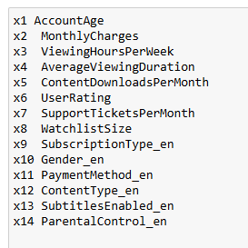

The trained model can now predict the likelihood of churn for new or existing customers. This information is crucial for retaining customers. By focusing on high-risk customers, businesses can:

**-** Reduce customer loss

- Maintain a healthy subscriber base

The effectiveness of the model will be evaluated using confusion matrix and accuracy score.

**Logistic regression**

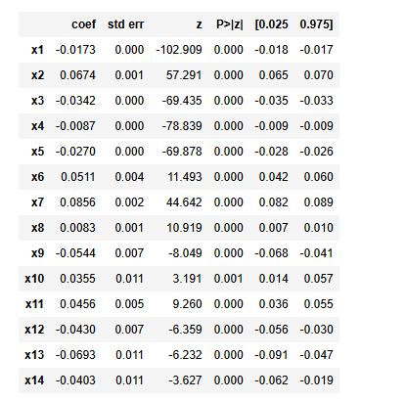

Account age, viewing hours per week. Average viewing hours content download per week, subtitles and parental control these are negative correlated coefficient means the less these values high likely to churn.